**AI BASED ASSISTANT FOR AUTONOMOUS ROBOTS**

|  |  |
| --- | --- |
| **GUIDE:** | **GROUP MEMBERS:** |
| Dr.S.Brindha | Mubashira Khatoon.M (19DC13) |
|  | Nimrukthi.S (19DC15) |
|  | Rajasurya.E (19DC19) |
|  | Stenson.T (19DC25) |

In this proposed system we aim to build an AI based assistant for autonomous robot. The AI based assistant will enable robots to respond to user questions related to the company in a human like manner which has the features including the voice assistance, navigation to the destination and understanding the expression and emotion.

Simpler autonomous robots rely on infrared or ultrasound sensors to help the robot “see” obstacles in their path. Higher-level robots such as autonomous vehicles use more complex sensors like cameras, radar and lidar (a detection system like radar, but using light from a laser). Combined with image-recognition software, these sensors allow the robot to precisely identify and categorize the objects they “see”, and make real-time “decisions”. AI will be running in a server utilizing Application programming interface (API). An app will be created in android with speech to text and text to speech conversion capturing. When a speech is detected it will make request to AI model in the server and process the request and give back text.Then the Text-To-Speech Transaction Tracking System (TTS) engine will convert the text back to speech.

**AI SOFTWARE**

**USER INPUT INTERFACE**

**ROBOTIC VOICE RESPONSE**

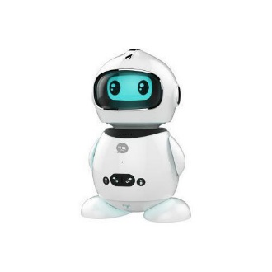

**USER INTERACTION MODULE**

**VOICE ASSISTANT MODULE**

**NAVIGATION MODULE**